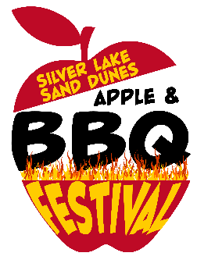
SLSD Apple & BBQ Festival
Classic Auto and ORV Show
September 10th, 2022

Trophy categories

Best Stock Original - Street
Best paint and/or detail - Street
Best old classic/vintage - Street
Best Modified/Hot Rod - Street
Best 2x4/4x4 truck – Street
Best 4x4 - Off Road
Best paint, wrap and/or detail - Off Road
Best modified ATV/UTV
Best Long Travel/Sand Rail/Sand Dragster
Best old classic dune vehicle - Ex: VW Beetle, VW Van, tub buggy, Bronco, etc. - Off Road Only

Best of Show All Categories

Judges voting system this year! No public votes.

