17th Annual Classic Auto & ORV Show
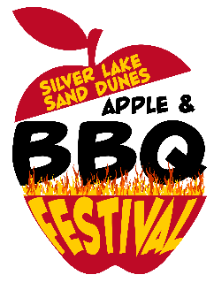
September 10th, 2022
10am-2pm

Dunetown Mall-SL Chicken Shack 8343 W Hazel Rd, Mears, MI
Door prizes
Show will go on rain or shine!
Live Music

Registration Fee $10.00

Register online through PayPal (link on www.applebbqfestival.com) no later than September 7th. Cash (exact preferred) day of show.

Show Timeline

Staging begins @ Dune Town Mall at 8:00am
Registration will be open until 9:45am
Show Time 10:00-2:00pm
Judges voting system
Trophies & Door Prizes awarded @ 2pm on SL Chicken Shack Stage

Simple Rules

Line starts forming at Dune Town Mall beginning at 8:00am (no earlier). You will be guided into place by festival parkers. No guaranteed parking spots!

If you try to park prior to being guided in, you will be escorted out and/or towed and disqualified!

No prior exit until awards are done (approximately 2:00pm)

There will be a judging voting system this year. No public votes. All categories will be included in Best of Show.

Trophies and Door prizes must be picked up at SL Chicken Shack Stage by 2:15pm

Thank you for your support! We appreciate your attendance!

